**PRACTICAL – 1**

**AIM:**

|  |
| --- |
| **Introduction to 8086 Microprocessor & Assembly Language Programming.** |

**THEORY:**

**8086 Microprocessor**

* Intel 8086 microprocessor is the enhanced version of Intel 8085 microprocessor. It was designed by Intel in 1976.
* The 8086 microprocessor is a16-bit, N-channel, HMOS microprocessor. Where the HMOS is used for "**High-speed Metal Oxide Semiconductor**".
* Intel 8086 is built on a single semiconductor chip and packaged in a 40-pin IC package. The type of package is DIP (Dual Inline Package).
* Intel 8086 uses 20 address lines and 16 data- lines. It can directly address up to 220 = 1 Mbyte of memory.
* It consists of a powerful instruction set, which provides operation like division and multiplication very quickly.
* 8086 is designed to operate in two modes, i.e., Minimum and Maximum mode.

## Features of 8086

The most prominent features of a 8086 microprocessor are as follows −

* It has an instruction queue, which is capable of storing six instruction bytes from the memory resulting in faster processing.
* It was the first 16-bit processor having 16-bit ALU, 16-bit registers, internal data bus, and 16-bit external data bus resulting in faster processing.
* It is available in 3 versions based on the frequency of operation −
  + 8086 → 5MHz
  + 8086-2 → 8MHz
  + (c)8086-1 → 10 MHz
* It uses two stages of pipelining, i.e. Fetch Stage and Execute Stage, which improves performance.
* Fetch stage can prefetch up to 6 bytes of instructions and stores them in the queue.
* Execute stage executes these instructions.
* It has 256 vectored interrupts.
* It consists of 29,000 transistors.

## Architecture of 8086

The following diagram depicts the architecture of a 8086 Microprocessor.

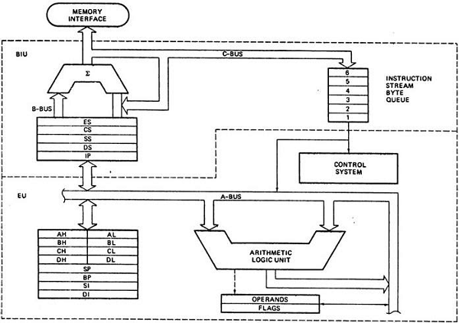

## 8086 pins configuration

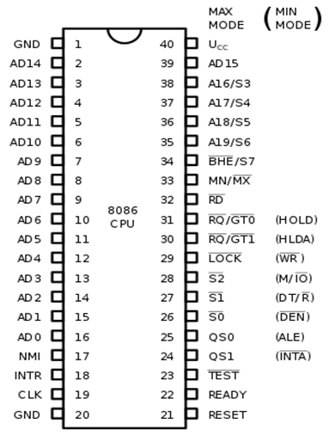

**Assembly Language Programming**

* The assembly programming language is a low-level language which is developed by using mnemonics. The microcontroller or microprocessor can understand only the binary language like 0's or 1's therefore the assembler convert the assembly language to binary language and store it the memory to perform the tasks.

**CONCLUSION:** We learnt about 8086 Microprocessor & Assembly Language Programming.